**Nodal Voltages**

Qs 1. Find Io using Node Analysis



**Solution**



**Qs 2**

Find V1 and V2 using Node Analysis



**Solution**





**Qs 3**

Find Vo using Node Analysis



**Solution**



**Qs 4**

Find Io using Node Analysis



**Solution**



**Qs 5**

A) Find Vo in the following circuit using Node voltage method

B) Find total power developed in the circuit



**Solution**



**Qs 6**

Find power delivered by the dependent source using node voltage method



**Solution**



**Qs 7**

Find Node voltages using Node analysis:



**Solution**

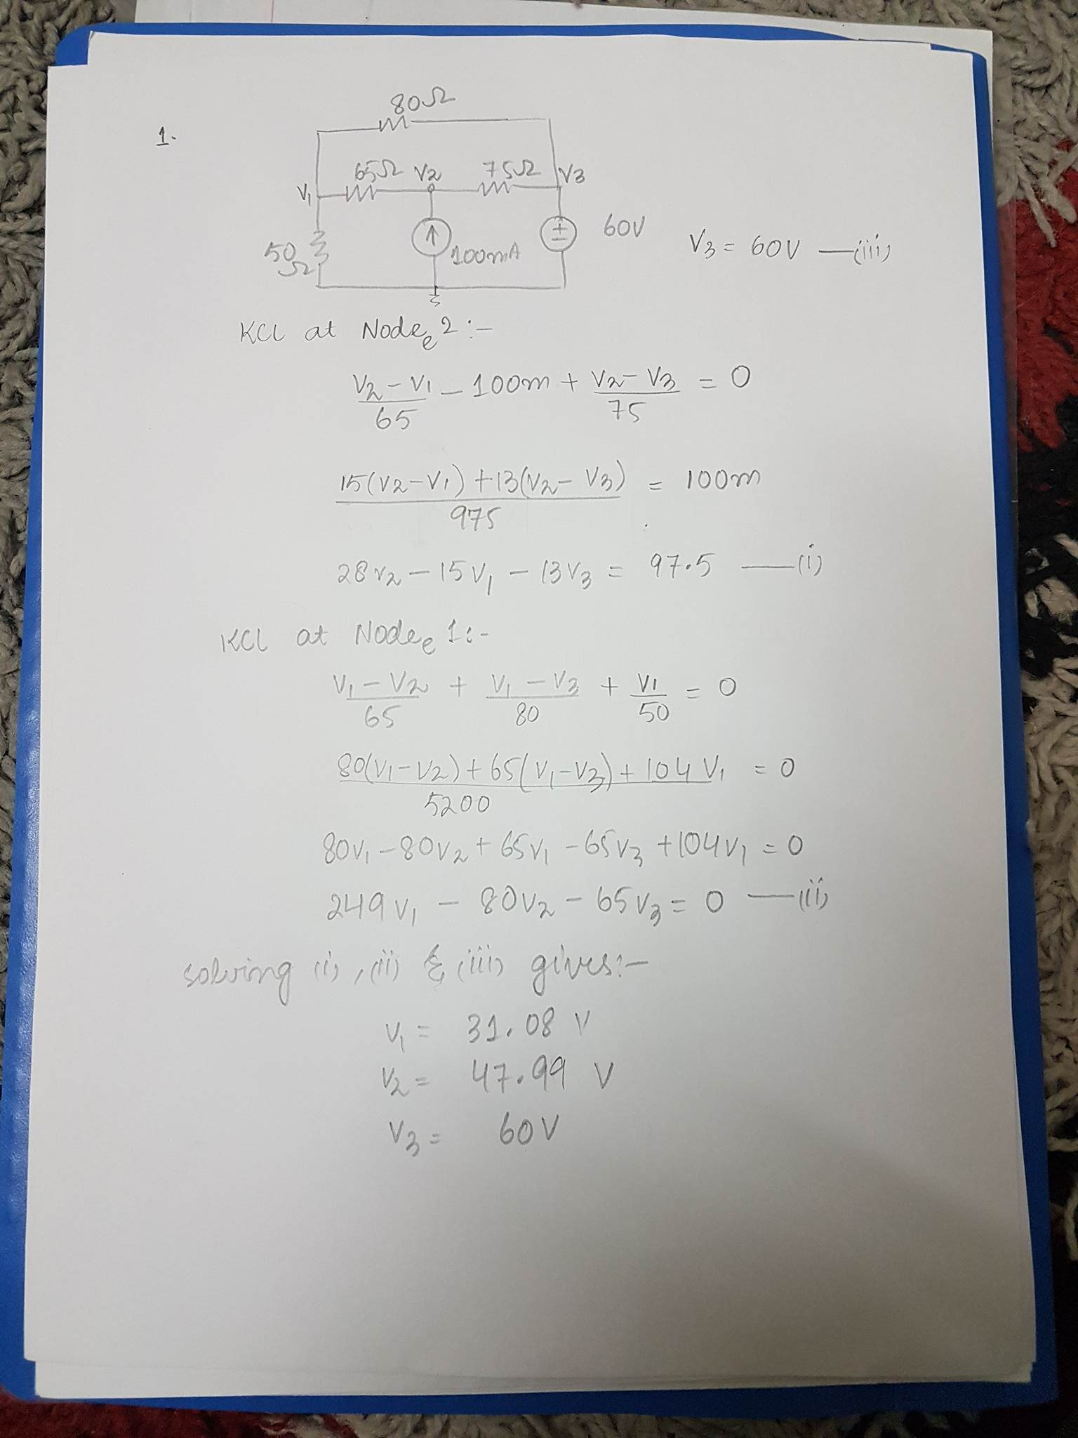

**Qs 8**

Find Node voltages using nodal analysis:



**Solution**

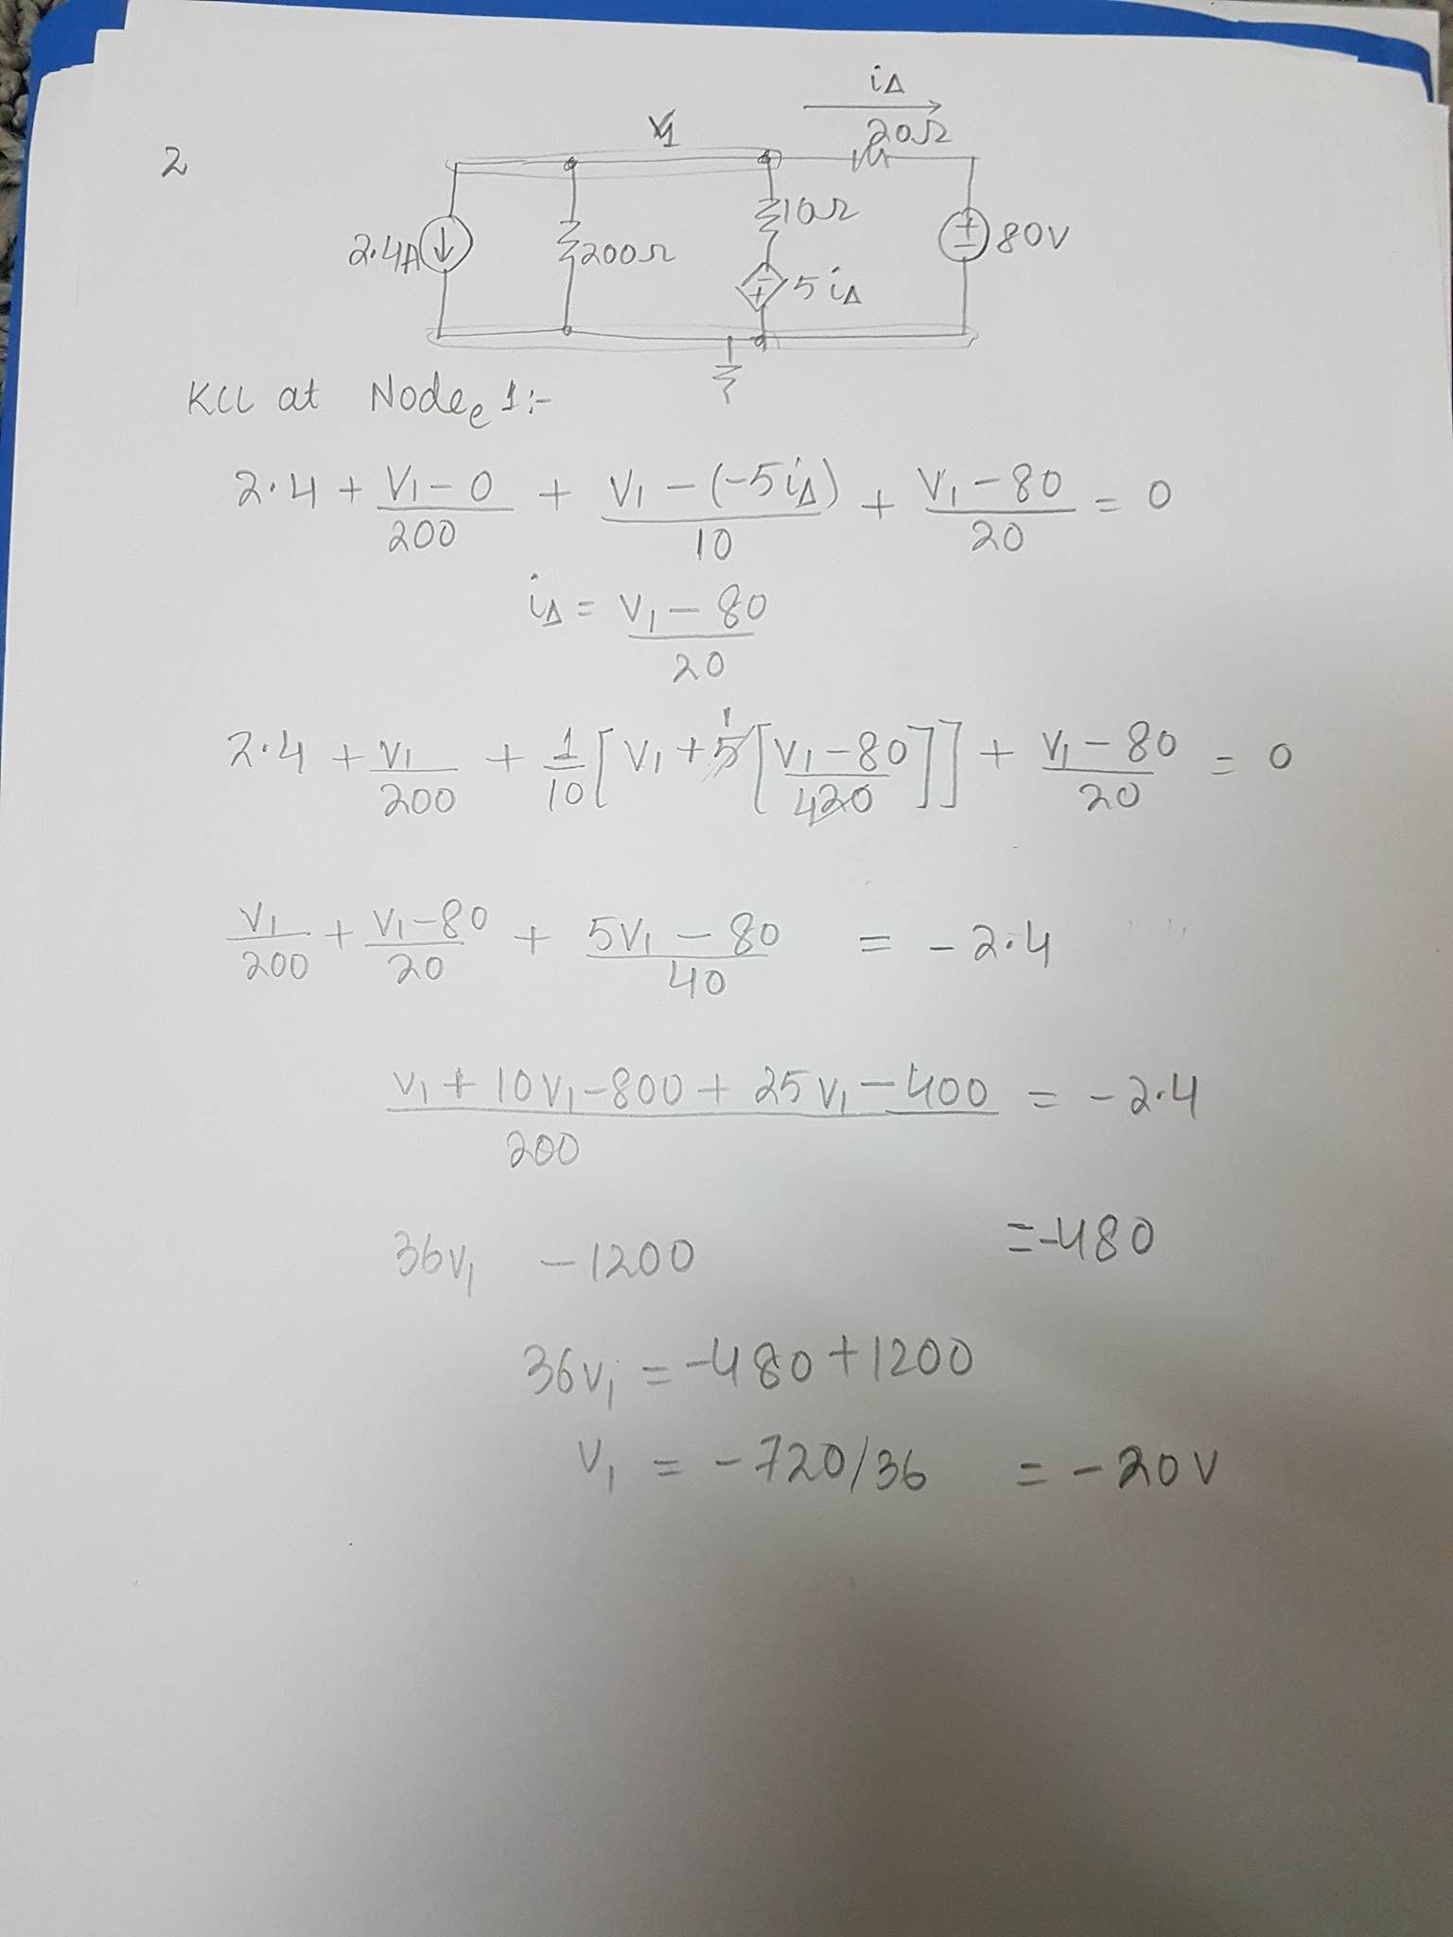

**Qs 9**

Find node voltages using Node analysis



Solution

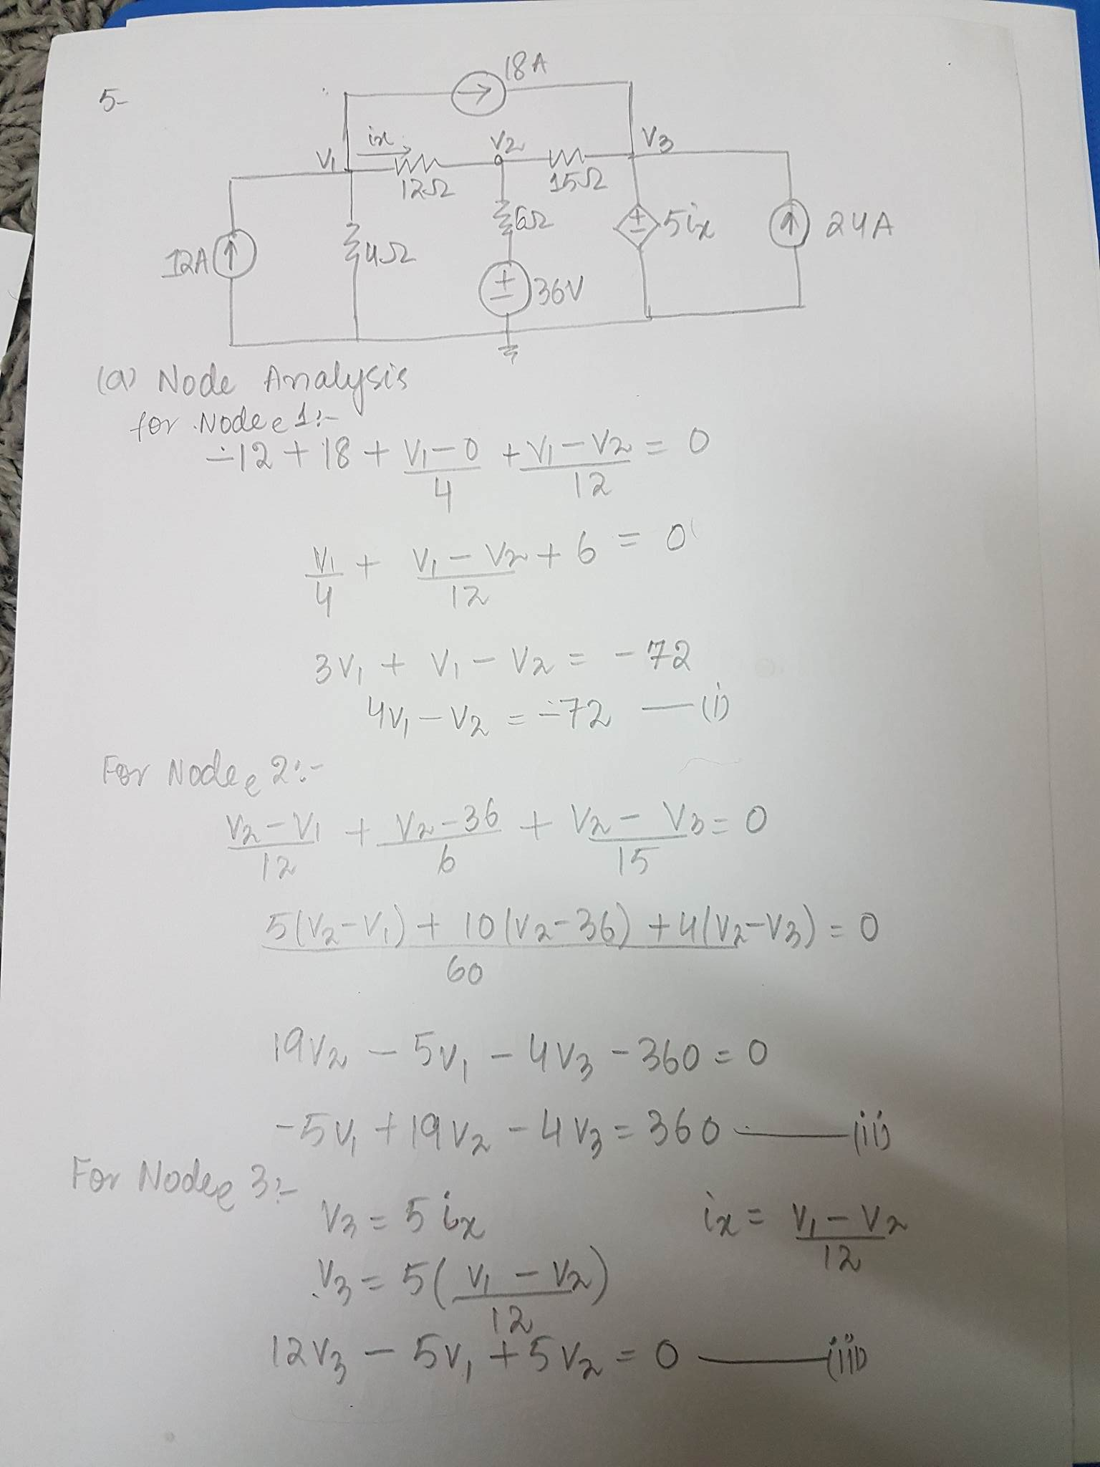

V1 = -14.84V, V2 = 12.63V, V3 = -11.447V

Qs 10

Find node voltages using Node analysis



Solution

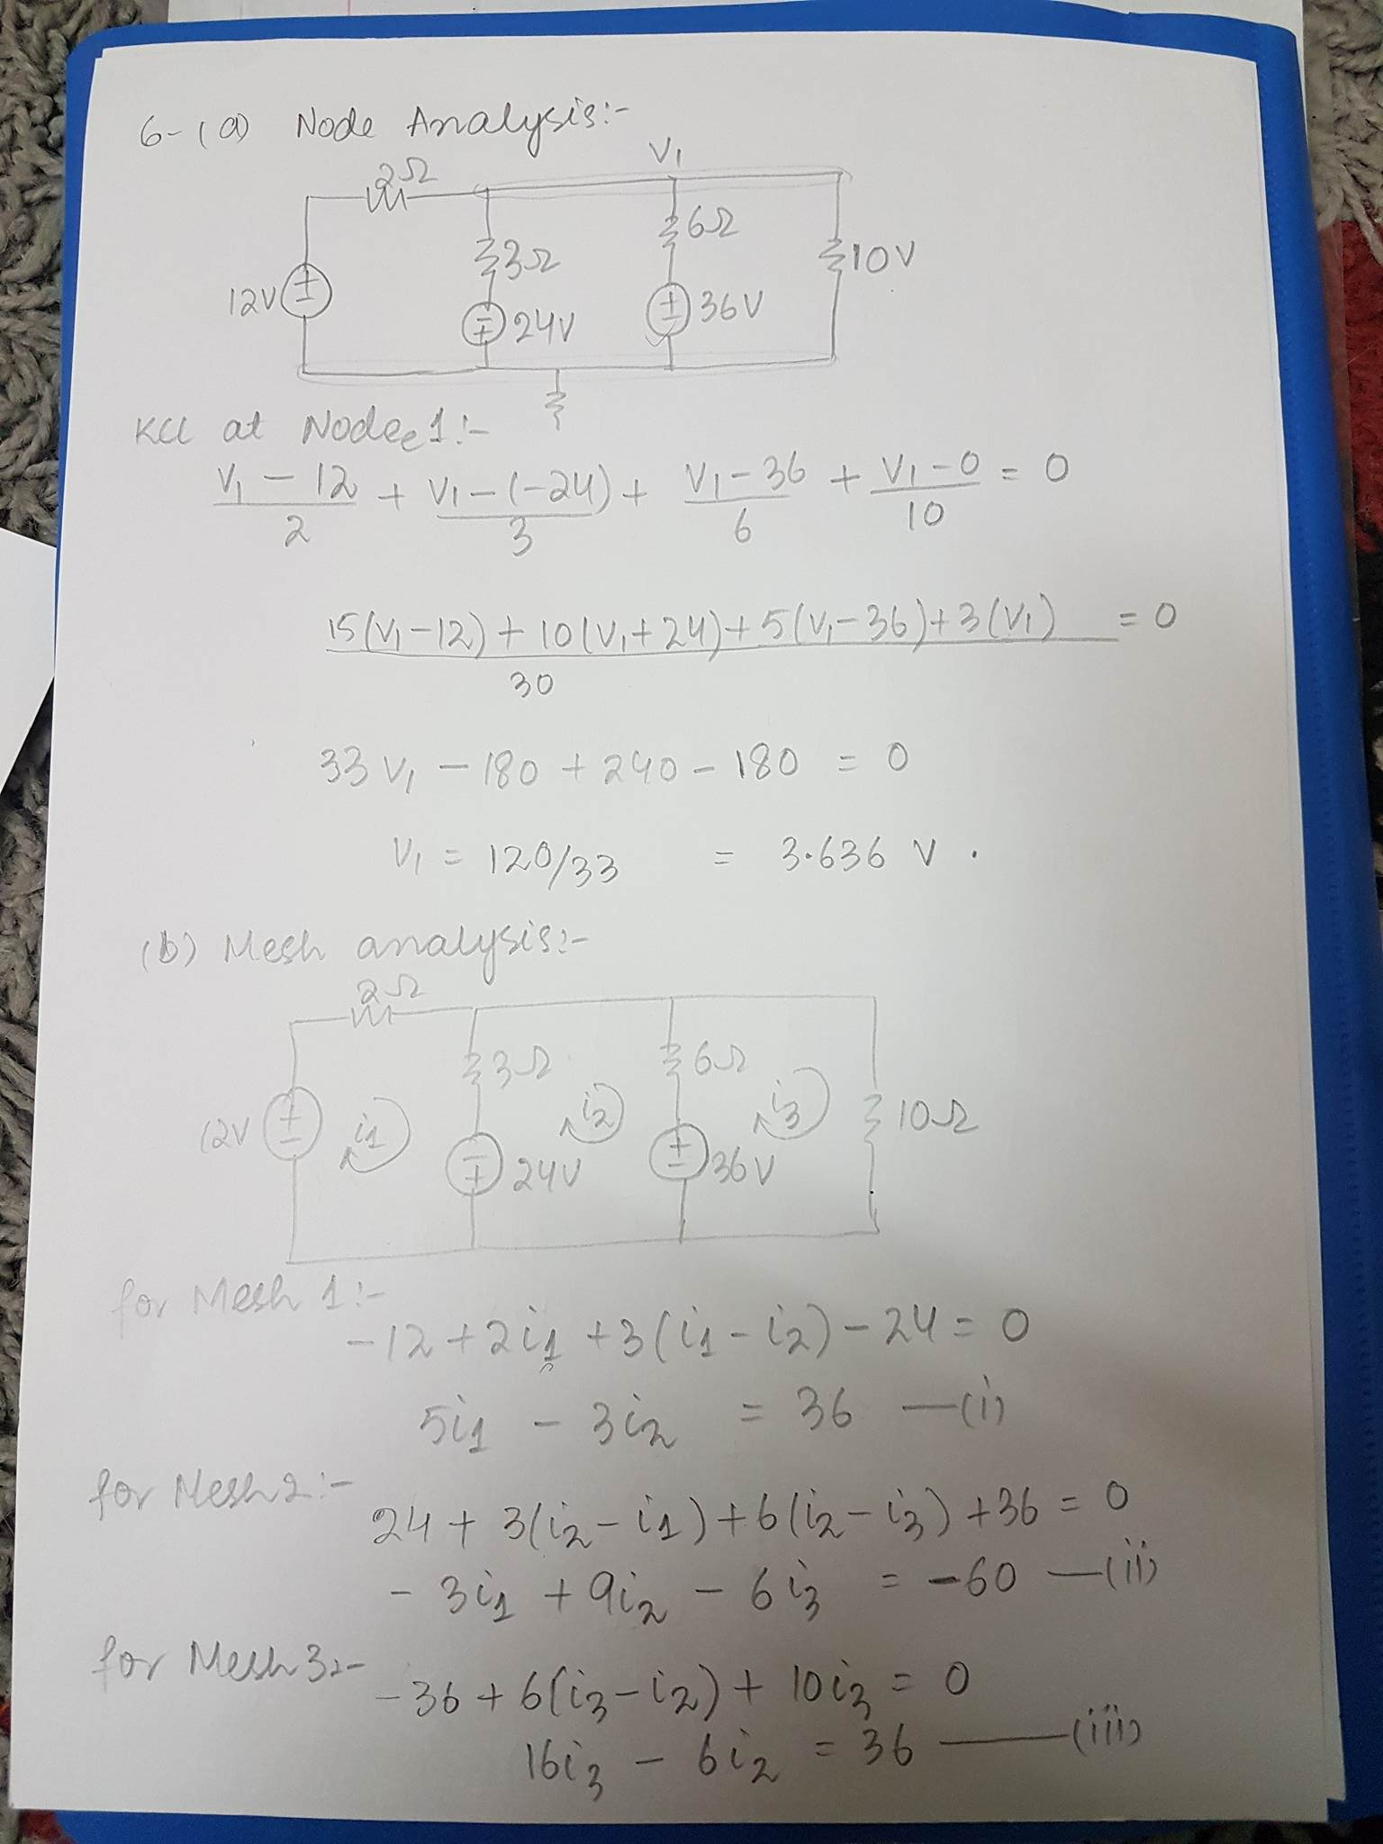

Qs 11 (A)Write Node Voltages Equation

(b) Write the symbolic equation (in terms of the node voltages) for the power in source Va.

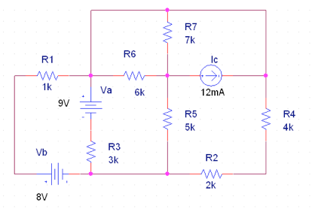

**Solution**

**a) Label Nodes**

Label each spot where two or more wires come together (this is every spot that has an independent node voltage). Here's how I labeled them:  
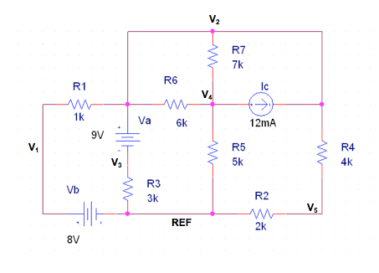  
Notice that node V2 is all the wire over the top and extends down to a dot on the right and in the middle of the circuit. That's all one node because it is all connected with wire (which means it is at the same potential).

**b) Node Voltage equations**

The equations are Kirchoff Current Law (KCL) equations. I'll write them as the sum of the currents leaving a node, so currents entering will be written negative. The sum should be zero.

**Node V1**

V1 = 8V.

This is not a KCL -- I can just directly to the solution here because of the voltage source connected to the reference node.

**KCL @ V2**

(V2 - V1)/1K + ia + (V2 - V4)/6K + (V2 - V4)/7K - 12mA + (V2 - V5)/4k = 0

Notice that node V2 always shows up positive and all the other node voltages always show up negative (because we are writing all the currents leaving). Also, I needed to label the current leaving node V2 down through the voltage source Va as a new unknown, ia. I could not write this as 9V because that's not a current and I need to write all currents for KCL.

**KCL @ V3**

-ia + V3/3K = 0

Notice that I must be consistent with my direction of ia. Since it was heading down through Va, now I need to write it negative because it is entering node V3 (and I'm writing all currents in terms of current leaving, so entering is negative).

**KCL @ V4**

(V4 - V2)/(6K || 7K) + 12mA + V2/5K = 0

Since the 6K and 7K have one end connected to V4 and the other end connected to V2 (their head and tail are connected), then they are in parallel (i.e., they share voltage). Thus I can write them both into the first current term in the equation above.

**KCL @ V5**

(V5 - V2)/4K + V5/2K = 0

**Extra Equation**

Because I added an extra unknown, ia, I need an extra equation. We can get it from the voltage source Va:  
V2 - V3 = 9V

**c) Power in Va**

To find the power dissipated by source Va, we cannot use Ohm's law because that only works for resistors. So we use the direct definition:   
P = V * I   
P = 9V * ia

**Qs 12**  Simplify And use Node-Voltage analysis to solve for the power delivered by the 35mA current source in the circuit shown.

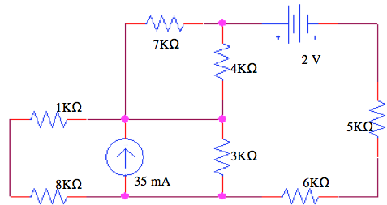

**Solution**

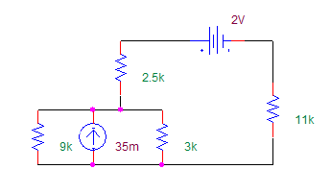 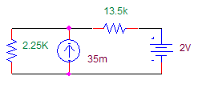

# Node-Voltage

The simplied circuit has three nodes: one at the bottom, one on the top left, and one on the top right. Let's call the bottom node the reference and label the other two:   
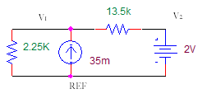   
KCL @ V1:   
V1 / 2.25K - 35mA + (V1 - V2) / 13.5K = 0   
V2 = 2V   
(because of the voltage source)   
Solving for V1, we get   
V1 = 67.7V 

# Power

Because we defined V1 with the "+" side where the label appears and the "-" side at the reference, the current is flowing into the "-" terminal, which is not the passive sign convention. Thus we need to reverse the polarity (the sign) on our voltage before computing power.   
P = -67.7V * 35mA = -2.37W

**QS 13** Solve for the current through the 5 ohm resistor and the current throughthe 18V source using Node-Voltage Analysis.

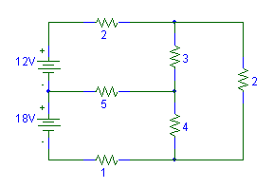

**SOLUTION**

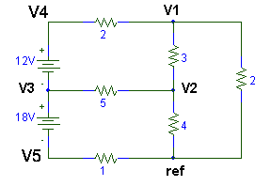

The reference node was selected and the three other nodes of the circuit were labeled V1, V2, and V3. Note that the node voltages are all with respect to the reference. So for example, V1 is the voltage with the "+" at the label V1 and the "-" at the reference node. The following equations can then be written:

**Current leaving V1**

(v1 - v4)/2 + (V1 - V2)/3 + (V1 - 0)/2 = 0

**Current leaving V2**

(V2 - V3)/5 + (V2 - 0)/4 + (V2 - V1)/3 = 0

**Current leaving V3**

We don't know the current through the 12V nor through the 18V, and we cannot use Ohm's law to find it, since they are not resistors. So add unknown current labels to the circuit, as shown:  
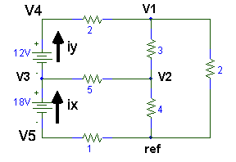  
Now we can write the KCL equations:  
iy + (V3 - V2)/5 - ix = 0

**Current leaving V4**

-iy + (V4 - V1)/2 = 0

**Current leaving V5**

ix + (V5 - 0)/1 = 0

**Extra Equations**

We now have five equations, but we have seven unknowns (the 5 unknown voltages plus 2 more unknown currents). We can get two extra equations -- just look at the voltage sources that caused the problems in the first place, where we had to add ix and iy. We'll write the voltage relationships between the node voltages:  
V4 - V3 = 12V   
V3 - V5 = 18V 

Now we have 7 equations and 7 unknowns. To solve these equations, let's simplify it down to fewer equations. Solve for V4 and solve for V5 from those last two we added:   
V4 = V3 + 12V   
V5 = V3 - 18V

Substitute these two equations into the previous five, so that we eliminate V4 and V5. We now have 5 equations and 5 unknowns:  
(v1 - [v3 + 12])/2 + (V1 - V2)/3 + (V1 - 0)/2 = 0   
(V2 - V3)/5 + (V2 - 0)/4 + (V2 - V1)/3 = 0   
iy + (V3 - V2)/5 - ix = 0   
-iy + ([V3 + 12] - V1)/2 = 0   
ix + ([V3 - 18] - 0)/1 = 0

Continue using substitution (Gaussian elimination) to narrow it down. Next, solve for ix in the last equation:  
ix = 18 - V3  
and substitute back to get 4 equations and 4 unknowns:  
(v1 - [v3 + 12])/2 + (V1 - V2)/3 + (V1 - 0)/2 = 0   
(V2 - V3)/5 + (V2 - 0)/4 + (V2 - V1)/3 = 0   
iy + (V3 - V2)/5 - [18 - V3] = 0   
-iy + ([v3 + 12] - V1)/2 = 0   
Next, solve for iy in the last equation:  
iy = ([v3 + 12] - V1)/2  
and substitute back to get 3 equations and 3 unknowns:  
(V1 - [V3 + 12])/2 + (V1 - V2)/3 + (V1 - 0)/2 = 0   
(V2 - V3)/5 + (V2 - 0)/4 + (V2 - V1)/3 = 0   
([V3 + 12] - V1)/2 + (V3 - V2)/5 - [18 - V3] = 0   
Now multiply each equation by a constant to clear out fractions. That is multiply by the Least Common Denominator (multiply first by 6, second by 60, third by 10).   
3 * (V1 - [V3 + 12]) + 2 * (V1 - V2) + 3 * (V1 - 0) = 0   
12 * (V2 - V3) + 15 * (V2 - 0) + 20 * (V2 - V1) = 0   
5 * ([V3 + 12] - V1) + 2 * (V3 - V2) - 10 * [18 - V3] = 0   
Next, multiply through   
3*V1 - 3*V3 - 36 + 2*V1 - 2*V2 + 3*V1 = 0   
12*V2 - 12*V3 + 15*V2 + 20*V2 - 20*V1 = 0   
5*V3 + 60 - 5*V1 + 2*V3 - 2*V2 -180 + 10*V3 = 0   
Now gather like terms:  
8*V1 -2*V2 -3*V3 = 36  
-20*V1 +47*V2 = 12*V3 = 0  
-5*V1 -2*V2 + 17*V3 = 120  
Continue with substitution until you have it solved.

